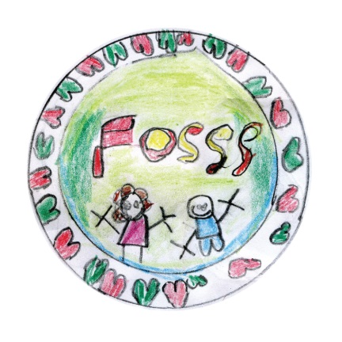
Friends of St Swithun’s School
FOSSS
Registered Charity Number : 1150288
Minutes Thursday 14th March 2014 – 7.00 – 7.30 pm @ School Hall
AGM Report Minutes
- Attendees: Zoe Farrow, Su Bland, Helen Hughes, Bill Hughes, David Ellis, Mike Clarke, Sarah Stafford, Tony Bland, Steve Cooper, Gail Cooper, Sophie Veneables
- Minutes from 2013 AGM were approved by the current committee.
- Chair’s Report – Current acting chair presented a look back at the 2012/2013 activities and achievements of the FOSSS, and then a look forward at the activities planned for the current year. Presentation attached in Appendix.
- Treasurer’s Report Current Treasurer presented the financial report. In summary the current financial position is strong due to increase profit from event due to strong spending control and stock management. Presentation attached in Appendix.
- Laura Gunner resigned as Secretary
- Election of Positions – 3 positions were open for election – the attendees voted the following members to the committee
Chair – Zoe Farrow – 1st Sophie Venables, 2nd Gail Cooper
Vice Chair – Su Bland – 1st Zoe Farrow, 2nd Annelies Denecker
Secretary – Annelies Denecker – 1st Mike Clarke, 2nd Sarah Stafford
Mike Clarke continues as Treasurer

Appendix
Chair’s report
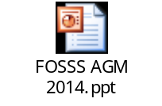

Treasurer’s Report

