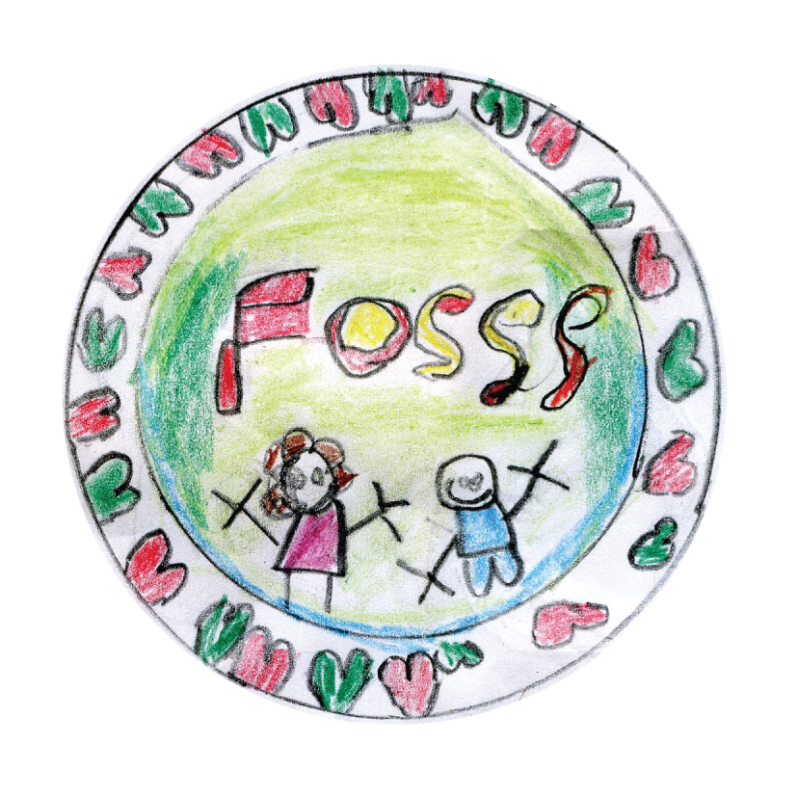
Friends of St Swithun’s School
FOSSS
Registered Charity Number : 1150288
Agenda Thursday 6th March – 7.30 – 9.30pm @ Zoe’s House
- Quiz Night (Friday 14th March) -
  - Ticket Sale Status:
    - 24 tickets sold so far
  - Kingfisher – require order Wed 12/03/14
  - Refreshments/Cutlery/Napkins
    - Tea & Coffee will be self-service: 20p
    - Remainder of drinks from the FOSSS cupboard will also be available
    - BYOB
- AGM (Friday 14th March, prior to Quiz Night)
  - Confirm vacancies : Chair (Zoe), Vice Chair (Su) & Secretary (Annelies/HF/…).
  - Suggestions for splitting roles/events > no longer making this official, we’ll do it as and when
  - Inform people of what we have done and what we will be doing
- Class donation – Confirm that letter has been sent to the teachers with the agreed value and process
  - Zoe created the letter and Tony Bland will review it.
- Summer Disco (Friday 16th May) –
  - HF - Update on progress/help required.
    - NEW: Meal deal: hotdog/pizza + drink + crisps/popcorn £2.50 (makes about £1.50 profit)
(Separate prices: Hotdog = £2, Fruitshoot = 75p, Can = 75p, Crisps/popcorn = 50p) Pay for it at the counter, but make sure we promote it in advance (so kids can be allocated appropriate pocket money or parents can make sure they have enough ;-) )
    - ‘Drop – Off’ : how should we manage those kids that are being ‘dropped off’ by their parents? Zoe/Su to check how this is being monitored/controlled/approved @ St. Jude’s (Caroline Tyrrell)
    - Food Order Asda : Zoe’s on the case, Annelies happy to help out.
    - Note: HF will be without internet connection for 7 weeks when moved into her new home, other members to help out posting information on Facebook.
  - Flyers – Annelies producing
    - To include ‘Meal Deal’
    - To go into bookbags on Monday March 31st
    - Make sure the event is on the calendar / newsletter
    - Boost/Promote via all the FB pages
  - DJ - Booked
  - License – has Mike submitted the request ?
- Summer Fair (Saturday 5th July)
  - Village Fete Theme
    - Activities, Stalls, Traders, Competitions, School Displays, Volunteers (see spreadsheet)
    - Meeting with Catherine Hobbs :
      - Can mums/dads come in and help out with some crafty preparations for the summer fair? (ie. Bunting making)
      - Are there any structural changes planned for the playgrounds, so we can start planning where all the activities will take place
- Family Bike Ride
  - HF can talk to someone at CTC who can think out a route, test ride it for risk assessment, they also offer a personalised saftety cycle course for adults for only £5
- Cash for Clothes
  - We’ll park this idea for now, as we already have a Salvation Army Clothes box available.
- Communication/ Website
- Finances
- Charity Status/ PTA Renewal
- AOB
  - Egg hunt run by the scouts on Friday April 4th, £1 > HF will promote by making sure that there are flyers on the tables during the Fish & Chips Quiz
  - Monthly FoodBank Collection via the school. HF knows that the situation for some people is quite dire and close to home. We should try and do more if we can.
  - STARS : A new initiative from Portsmouth City Council, which will tick a lot of Ofsted boxes. This could kick of new initiatives, such as Park & Stride… there is no cost to St. Swithun’s (HF drives this)
  - Meeting to be scheduled with Miss Hobbs, Liz & Zoe/Su (more?)
    - Next FOSSS sponsored item: classrooms; what exactly? 1 classroom? 1 item in every classroom? What exactly is needed? Can we try and bid for some funding? We need some more clarity around this topic to understand how FOSSS can help out most effectively.
    - Discuss the items for the Summer Fair
    - Discuss the option of doing a monthly ‘foodbank’ collection idea.
    - Discuss the STARS idea (HF probably needs to pitch it)
    - We would like more ‘notice boards’ to communicate with the parents
  - Fund raiser idea 1: sell Krispy Kremes as an end of term treat > Let’s try it now before Easter break!
  - Fundraiser idea 2: reintroduce the tea towels
  - Fundraiser idea 3 : creation of ‘general’ cards > Su & Nikki working on this
  - Change the magnet with all FOSSS activities, to a FOSSS logo magnet with a ‘card’
  - Marketplace has been taken down, due to low usage
  - Jeff Gosden needs to be contacted to get the Twitter password

- Next Meeting – April 3rd

